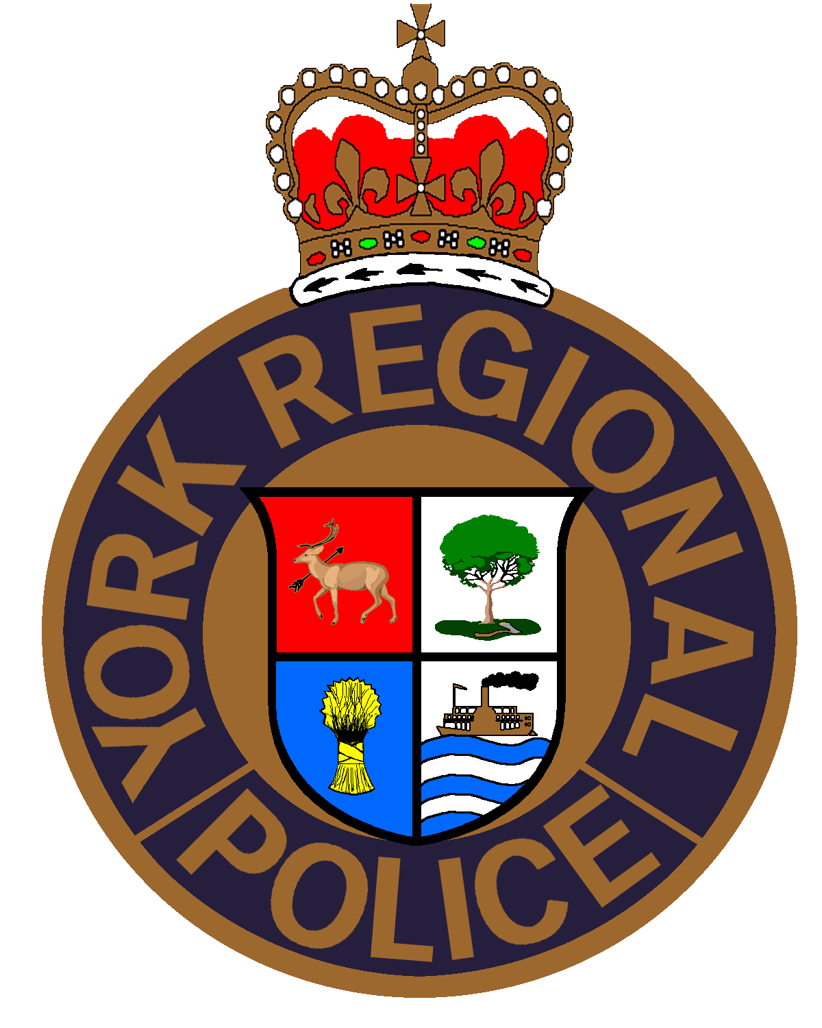

**TAKE OUR KIDS TO WORK DAY**

**Waivers, Participant Release & Assumption of Risk**

**Transportation Waiver**

I give permission for my child to ride as a passenger in a York Regional Police vehicle for the purposes of activities related to **Take Our Kids to Work Day**. In consideration for this transportation provided by York Regional Police, I HEREBY WAIVE any and all claims which, but for this release, my child or I may have or may hereafter acquire against York Regional Police, its officers or employees, the Regional Municipality of York or the Regional Municipality of York Police Services Board, arising directly or indirectly from my child being transported in a York Regional Police vehicle, and I AGREE TO PAY promptly any damages, costs or charges incurred by York Regional Police as a result of my child's actions while being transported in a York Regional Police vehicle.

**Photo Waiver**

In the course of this activity, pictures may be taken and recordings may be made. Please confirm that you are willing to have your, or your child's/ward's photograph or voice used by York Regional Police for police publications, presentations, displays or on our website. I give permission to York Regional Police to photograph and/or record on still photographs, motion picture film, audio tape and/or video tape and to use this material, in whole or in part, through the media of television, film, Internet, multi-media presentation, radio, audiotape, videotape or in printed form or display form produced by York Regional Police. I assign and transfer to York Regional Police any and all rights, including copyright, which I may have in this material.

**Collection of Personal Information**

Personal information contained on this form is collected pursuant to the Municipal Freedom of Information and Protection of Privacy Act and the Police Services Act and will be used for the purpose of processing your child's registration form for Take Our Kids to Work Day. Questions about the collection, use and sharing of personal information may be directed to: Supervisor of Community Safety Village, York Regional Police; Tel: 1-866-876-5423 ext. 2880 or the Administrative Assistant at ext. 2881.

**Participant Release, Waiver and Assumption of Risk**

Please read carefully before signing.

I, (Parent/Guardian Name) _________________________________________, hereby affirm that I (we) have been advised and informed of the inherent hazards involved in this activity. I (we) confirm that *(Participant Name)*______________________ is healthy and there are no physical reasons why he/she cannot participate in this activity. I (we) understand and agree that the York Regional Police Take Our Kids to Work Day of which *(Participant Name)*_______________________ is a participant, is not responsible for or in control of this activity. Further, I (we) freely and voluntarily choose (give permission) to participate in this activity and I (we) fully assume any and all risks and hazards associated with or that may result from participation in this activity. I, for myself, my parent(s)/guardian(s), my heirs, executors, administrators, successors, assigns and invitees, HEREBY RELEASE, WAIVE AND FOREVER DISCHARGE York Regional Police, The Regional Municipality of York, its Chair, Councillors, officers, employees, contractors, and The Regional Municipality of York Police Services Board OF AND FROM ALL claims, demands, damages, costs, expenses, actions and causes of action, whether in law or equity, in respect of death, injury, loss or damage to my person or property, HOWEVER CAUSED, arising or to arise by reason of participating in this activity. I (we), understand clearly that by signing this Release, Waiver & Assumption of Risk, I (we) will be forever prevented from suing or otherwise claiming against York Regional Police, The Regional Municipality of York, its Chair, Councillors, officers, employees, contractors, and The Regional Municipality of York Police Services Board with respect to any matter arising from this activity.

**BY SIGNING THIS AGREEMENT, I (WE) ACKNOWLEDGE HAVING READ, UNDERSTOOD AND AGREED to the above TERMS, WAIVERS, RELEASE AND ASSUMPTION OF RISK.**

________________________________________ ___________________________________________ Participant Name Parent Signature

________________________________________

Date